**GIT**

The folder hierarchy is shown below. There is a parent directory called **OOPS**, and inside of it

are four more directories named

**Abstraction**, **Polymorphism**, **Inheritance**, and **Encapsulation**. You must use the command

line to move the **Function_Overloading.txt** and **Operator_Overloading.txt** from the **Polymorphism** directory to the **Encapsulation** directory.

**Screen 01:**

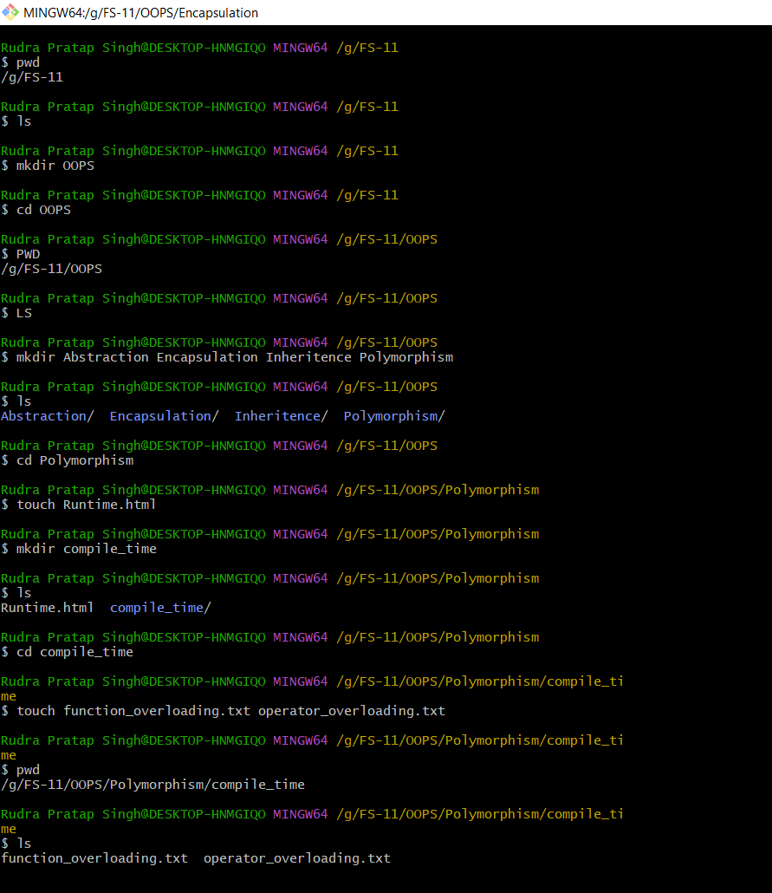

**Screen 02:** 